**API Gateway**

**#Task**

**Create a REST API gateway endpoint which will invoke a lambda function and return some json to the client.**

1. We’ll create a lambda function called Transaction Handler

2. We’ll set up a transaction resource and set up a GET API. That GET API will forward a request to lambda function and get a hard coded response back to the client.

Create a lambda function

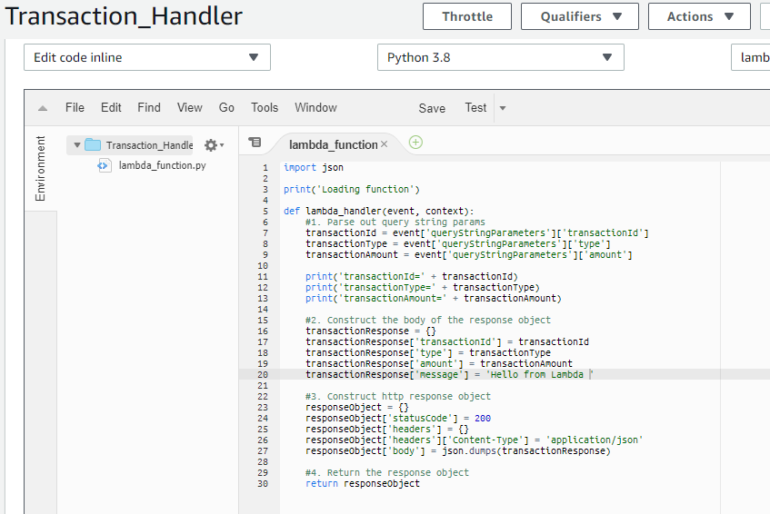

Now create a REST API Gateway

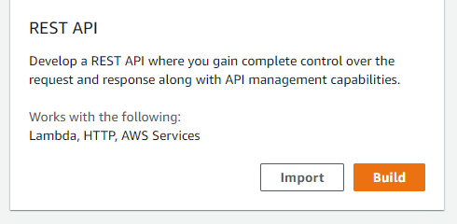

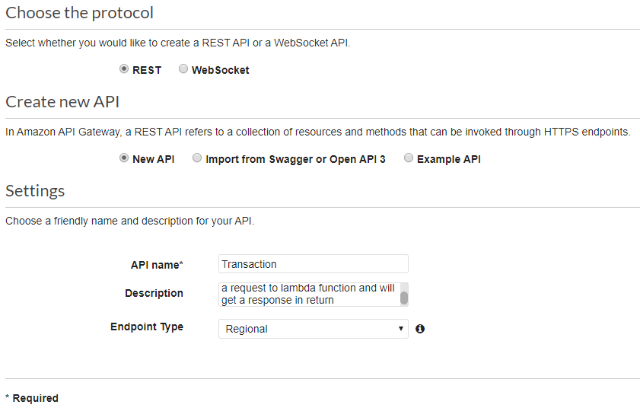

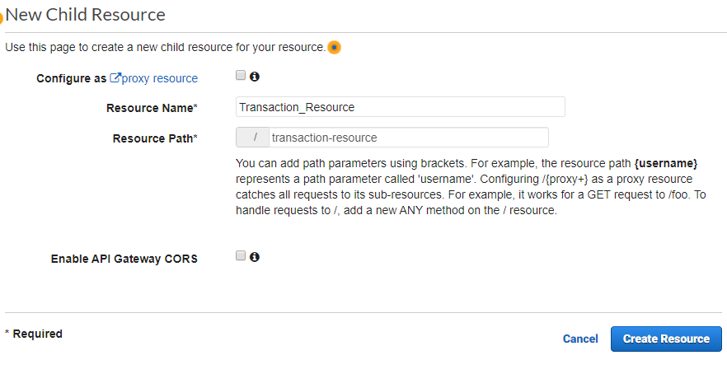

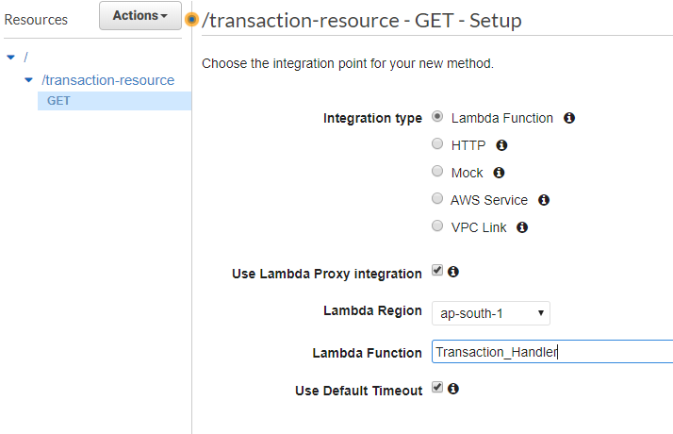

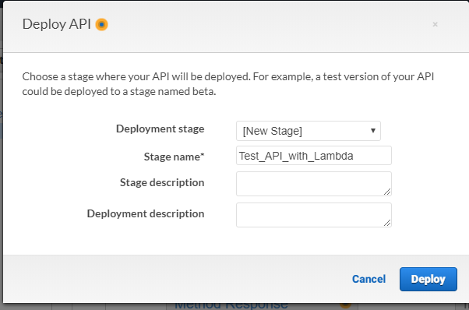

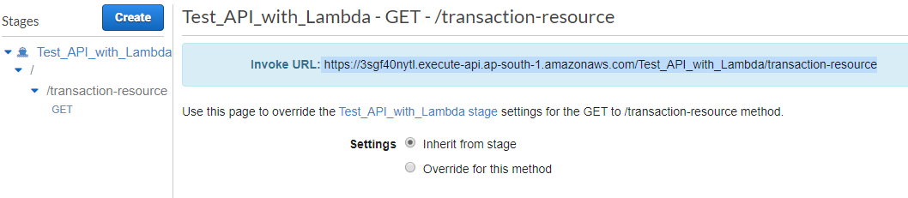

Copy the URL

And pass parameters



output/response

